**Alan shah**

G5

Np03cs4a220214

**Instruction:**

Complete all questions in **1 hour.**

1. Draw the logic diagram of the following gates using logsim and complete the

Truth tables.

1. AND

|  |  |  |
| --- | --- | --- |
| **A** | **B** | **A.B** |
| **0** | **0** | **0** |
| **0** | **1** | **0** |
| **1** | **1** | **1** |
| **1** | **0** | **0** |

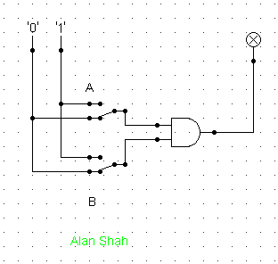

1. NOR

|  |  |  |
| --- | --- | --- |
| **A** | **B** | **A.B** |
| **0** | **0** | **1** |
| **1** | **0** | **0** |
| **1** | **1** | **0** |
| **0** | **1** | **9** |

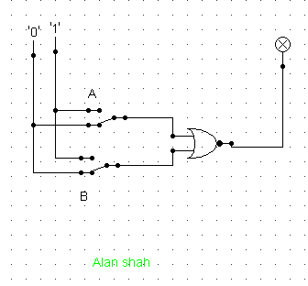

1. OR

|  |  |  |
| --- | --- | --- |
| **A** | **B** | **A.B** |
| **0** | **0** | **0** |
| **0** | **1** | **1** |
| **1** | **1** | **1** |
| **1** | **0** | **1** |

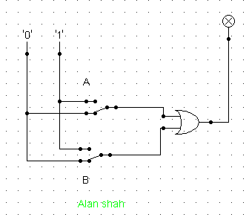

1. NAND (using NOT and AND)

|  |  |  |
| --- | --- | --- |
| **A** | **B** | **A.B** |
| **0** | **0** | **1** |
| **1** | **0** | **1** |
| **0** | **1** | **1** |
| **1** | **1** | **0** |

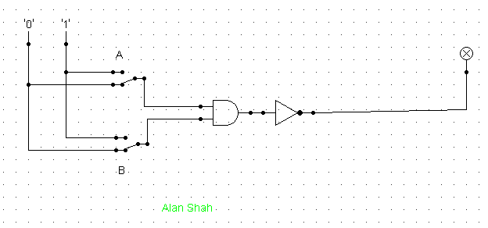

1. XOR using AOI

|  |  |  |
| --- | --- | --- |
| **A** | **B** | **A.B** |
| **0** | **0** | **0** |
| **0** | **1** | **1** |
| **1** | **1** | **0** |
| **1** | **0** | **1** |

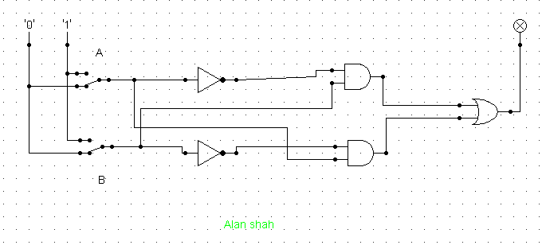

1. Use LogSim to build the equivalent circuit for the following Boolean equations.

Prove that the expressions are equivalent by computing truth table.

$$!\left(A+B\right)=!A.!B$$

|  |  |  |  |
| --- | --- | --- | --- |
| A | B | !(A+B) | !A . !B |
| 0 | 0 | 1 | 1 |
| 0 | 1 | 0 | 0 |
| 1 | 0 | 0 | 0 |
| 1 | 1 | 0 | 0 |

1. Draw the following circuit of half adder using LogSim.

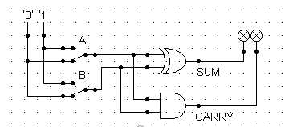

1. Draw full adder using Logsim and construct truth table.

|  |  |  |  |  |
| --- | --- | --- | --- | --- |
| A | B | CI | S | CI |
| 0 | 0 | 0 | 0 | 0 |
| 1 | 0 | 0 | 1 | 0 |
| 0 | 1 | 0 | 1 | 0 |
| 1 | 1 | 0 | 0 | 1 |
| 0 | 0 | 1 | 1 | 0 |
| 1 | 0 | 1 | 0 | 1 |
| 0 | 1 | 1 | 0 | 1 |
| 1 | 1 | 1 | 1 | 1 |

1. Draw the logic circuit for the following Boolean equations using logsim simulator.
   1. AB+CA picture containing white, shelf

      Description automatically generated
   2. A(B+C)

* 1. X’Y’Z’

